Individual Multimedia Project: Initial Proposal
The aim of the individual multimedia project is to design and successfully run a website which focuses on Cardiff City Football Club. It will contain features on up-and-coming fixtures, results, player profiles, match-reports, as well as other content related to the club. It’s a website which will ultimately be used by fans of the club to stay up-to-date with all the goings on, providing them with everything they need to know about Cardiff City.
In order to achieve the deliverables, it is important to not only combine all these features listed above onto one website, but to also make sure that the webpage is of a high standard. It’s imperative to break the deliverables down further into project milestones, or objectives. Research is vital in order to break the project down into these numerous objectives.
Initial research suggests that the best websites in the same area of speciality (sport/ football), work best when they interact with the audience and also when they are easy to use. This can be achieved with a nice layout and plenty of buttons on the top of the page, which will act as a navigation menu, guiding viewers through the site. With this in mind, a website which is user friendly and easy on the eye is of the upmost importance, for this to be achieved a lot of thought must be placed on the design aspect.
Below is an example of the type of buttons which will be included on the top of the webpage, making navigating through the site a far easier task.
Also from this initial research, it is clear to see that in order for the website to be user friendly, it should also engage viewers. This can be achieved by including features such as polls, as well as using social networking as an advantage, rather than a hindrance, including share buttons – one click means that the site can be seen by hundreds (and with time, possibly thousands) of people across different formats.
Another objective is to narrow down the scope of what will be included on the completed website, making sure that it is of the highest standard possible. It’s important not to overcrowd the website, but finding the right balance between it being overcrowded and a little empty needs to be found.
The website itself will include a range of Cardiff City related multimedia, such as relevant pictures, videos, sound-bites, etc. As well as this, the completed website will contain a collection of Cardiff City blogs, giving a fans view of the latest goings on at the football club, and again showing its user friendliness by interacting with the viewers, asking them to get involved. An in-depth look at all the clubs players will also be included on the site, as well as all the latest news, including fixtures and results.
The methodology differs for each aspect of the building of the site. It could include recording videos, editing them using Premier Pro and then uploading them onto the site, or perhaps it will involve finding the relevant multimedia online and asking for permission of its use on the sight. But either way, in order to achieve many of the tasks, various different software and packages will have to be used.
A spreadsheet, for example, can be created using Microsoft Excel, which can store details of all the latest results, scorers, match facts and any other details. The website itself can be created using Adobe Dreamweaver, which will help build a site using a basic template. A programme such as Adobe Fireworks (or even photoshop to an extent) could also then be used in the process of creating the website, not only can it be used to aid in ‘amplifying’ the website with banners and links, but also for enhancing images, before being placed online.
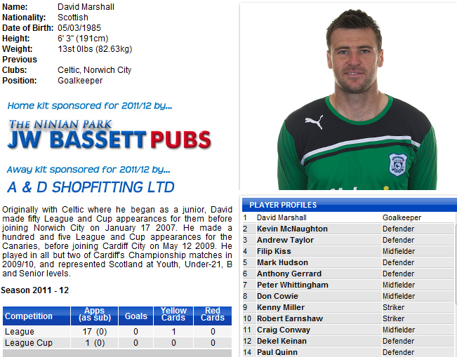
Microsoft Access could also be used to store details on each player, such as name, age, height, position, D.O.B, etc, in one database. This could then be linked to the website in a pop-up box which opens in a new tab - again showing the importance of user interaction and also help create a professional looking site.

The screenshot above is an example of the type of player database that will be found on the website. It includes, as mentioned above, details regarding the players, as well as an easy to use link to each individual player (circled) which makes the site easy to use.
The building of the website itself will obviously bring some difficulties; permission will be needed if pictures/ blogs/ any sort of media is taken from somewhere else. The different types of software available may also arouse some issues, but on the whole, it shouldn’t be a major problem.
Though making sure not to overcomplicate the website, flash content may be used in order to make the site more visually interesting and to also make it more interactive – after all, this is the overall aim of the project.
With initial research in mind, as well as a proposal which outlines the aims and objectives, it’s fair to say that this project is certainly feasible. A high quality, well run website which focuses on Cardiff City, as well as interacting with the audience and being easy to navigate through, is what should be reached upon completion – it will be challenging, but certainly achievable.

